**Name – Majahar Mahamud Kazi**

**Div – B Batch – B2**

**Roll no. – 322036 PRN no. – 22110729**

**Assignment 6**

**Aim:** Write an ansible-playbook to install nginx on target servers.

**Theory:**

1. **What is YAML ?**

YAML stands for "YAML Ain't Markup Language". It is a human-readable data serialization format used for configuring applications, storing data, and exchanging information between systems. It is often used in configuration files and is used as a replacement for XML or JSON. YAML uses indentation to define the structure of data and uses a minimalistic syntax that makes it easy to read and write by humans.

1. **What is Ansible ?**

Ansible is an open-source automation tool used for configuration management, application deployment, and orchestration. It uses a declarative language called YAML to define the configuration of systems and applications, and it executes tasks in parallel on multiple systems over SSH. Ansible is designed to be simple, easy to use, and highly scalable, and it does not require any agents or additional software to be installed on the target systems. Ansible can be used to automate tasks such as server provisioning, software installation, system updates, and application deployment, among others.

**STEPWISE IMPLEMENTATION:**

Architecture:

Ansible Master

Node 1

Node 2

Node 3

Steps:

Create 4 EC2 Instances on AWS

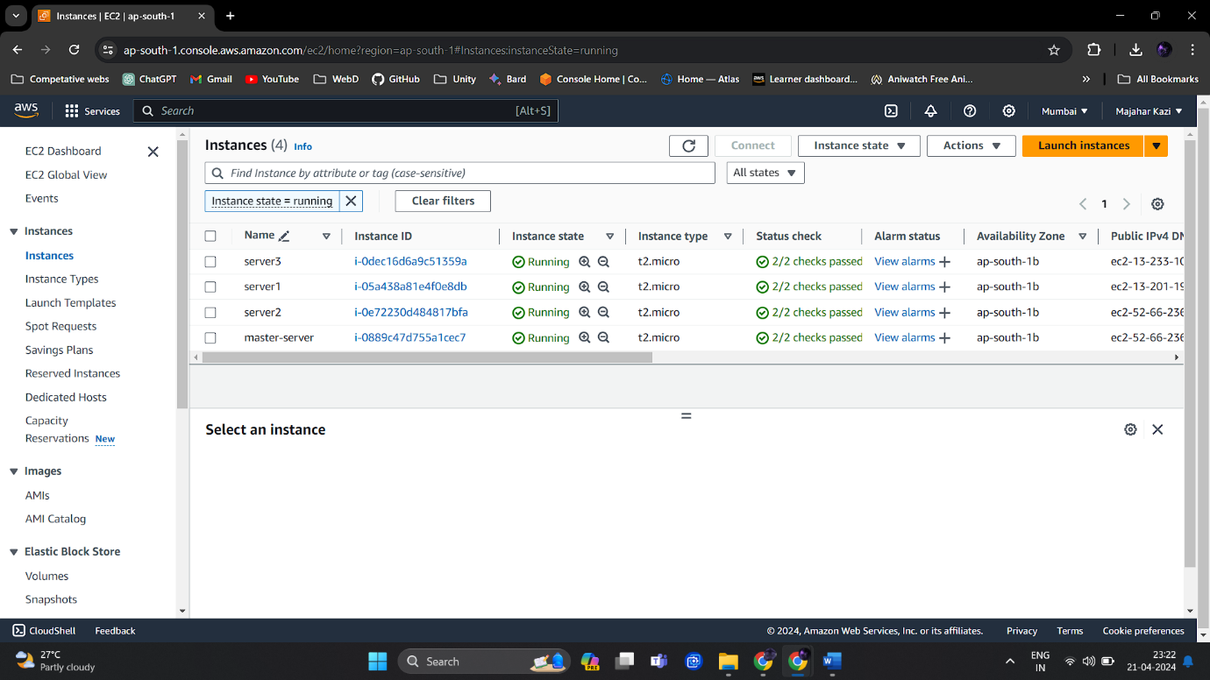

Here we have Created 1 Master & 3 Slaves Servers.

Run ‘yum update -y’ on all Instances & Install ansible on the master server.

> Generate ssh key on Ansible-master using command

ssh-keygen

This will generate keys on the master server

Now copy the public key from the master server and paste it into the authorized_keys of the slave servers.

To check for ssh authentication:

ssh ubuntu@PrivateIP

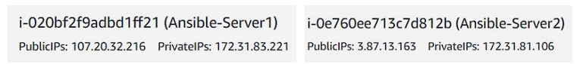

Here we have cross verified the ssh-authentication for server-2 Use the exit command to close the ssh connection

make a directory named ansible using the mkdir ansible

Create two yaml files namely

1. inventory.yaml
2. playbook.yaml

The inventory.yaml file must consist of the the private IP addresses of the slave servers

The playbook.yaml file must contain the ansible script which is to be executed.

Run the playbook.yaml & inventory.yaml files

**Output:**

**Conclusion:**

We have successfully written an ansible-playbook to install nginx on target servers. We have also explored domains like ansible and yaml.

Author – Majahar Kazi

Sunday 21 April 2024 23:54:40 PM IST